# Subject:

The website is based around a music shop, this is a music shop based in Sheffield that specialises in local artists.

# Purpose:

The purpose of the website is to show what products the shop sells, so the different albums by different artists. It is can also be used to help a user find where the shop is. It will also be used to advertise a loyalty scheme and inform the user of what the website’s purpose is as a whole.

# Target Audience:

The target audience will be people interested in music from the age 15+, this way products aimed at a more mature audience can be sold. The target audience should also have an interest in local music

# Software tools:

The software used to make the website will be Notepad++, this is because it can be used to edit all three languages used: CSS, JavaScript and HTML.

# Information Content:

In the website, there will be information detailing what current and future releases there is, this is for both local music and regular music from anywhere, there is also a page detailing the location of the shop, using a map to assist in finding it, there is also contact information and opening times on this website. There will also be a page describing the loyalty scheme.

# Navigation devices:

The website will have a navigation bar at the top of the page, this is to allow for easy navigation around all pages. There will also be odd hyperlinks within the body where necessary for access to the other pages other than the navigation bar.

# Uploading the Website:

The website will be uploaded to the allocated area on the College’s network, this is so it doesn’t go completely live, just there for tutor’s to find it.

# Outline of Page Content

## Page 1:

Contains an introduction to what the shop is and what is actually within the website, will have some pictures that relate to the scenario (music shop.)

## Page 2:

The second page will contain all the details of things being sold at the music shop, including all new releases from all musicians, as well as local musicians. It will also include special offers, such as loyalty schemes.

## Page 3:

Will include details of the location of the shop, with embedded google maps to show where it actually is, instead of just giving an address. It will also include the opening times of the shop, this is because there isn’t enough information there to have its website. The fourth page will include the contact details of the store.

## Page 4:

This page also includes complete details about the special loyalty scheme offer. This means that there is a way to fill out a form with your name, email, post code and musical interests to allow for information to be saved within a variable, which will then be printed to the user in place of the form.

# Network Diagram:

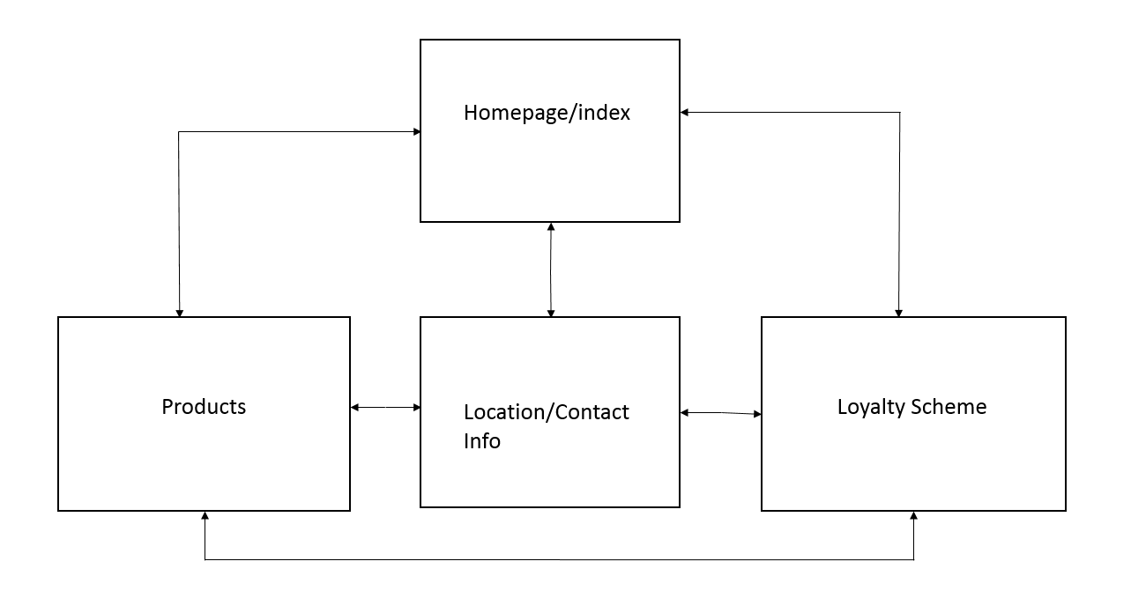

Page 4

Page 3

Page 2

Page 1

# Colour Scheme:

The colour scheme of the website is red, white, black and grey. The font used will be Tahoma.

The navigation bar of the website will be red, with the text within it being white. The body of the website will be white, with black text for main headings and grey text for smaller headings (h3 onwards.) The logo for the website will be white text upon a black background. The background of the webpage itself will be grey and black and the hyperlinks within the text will be red.